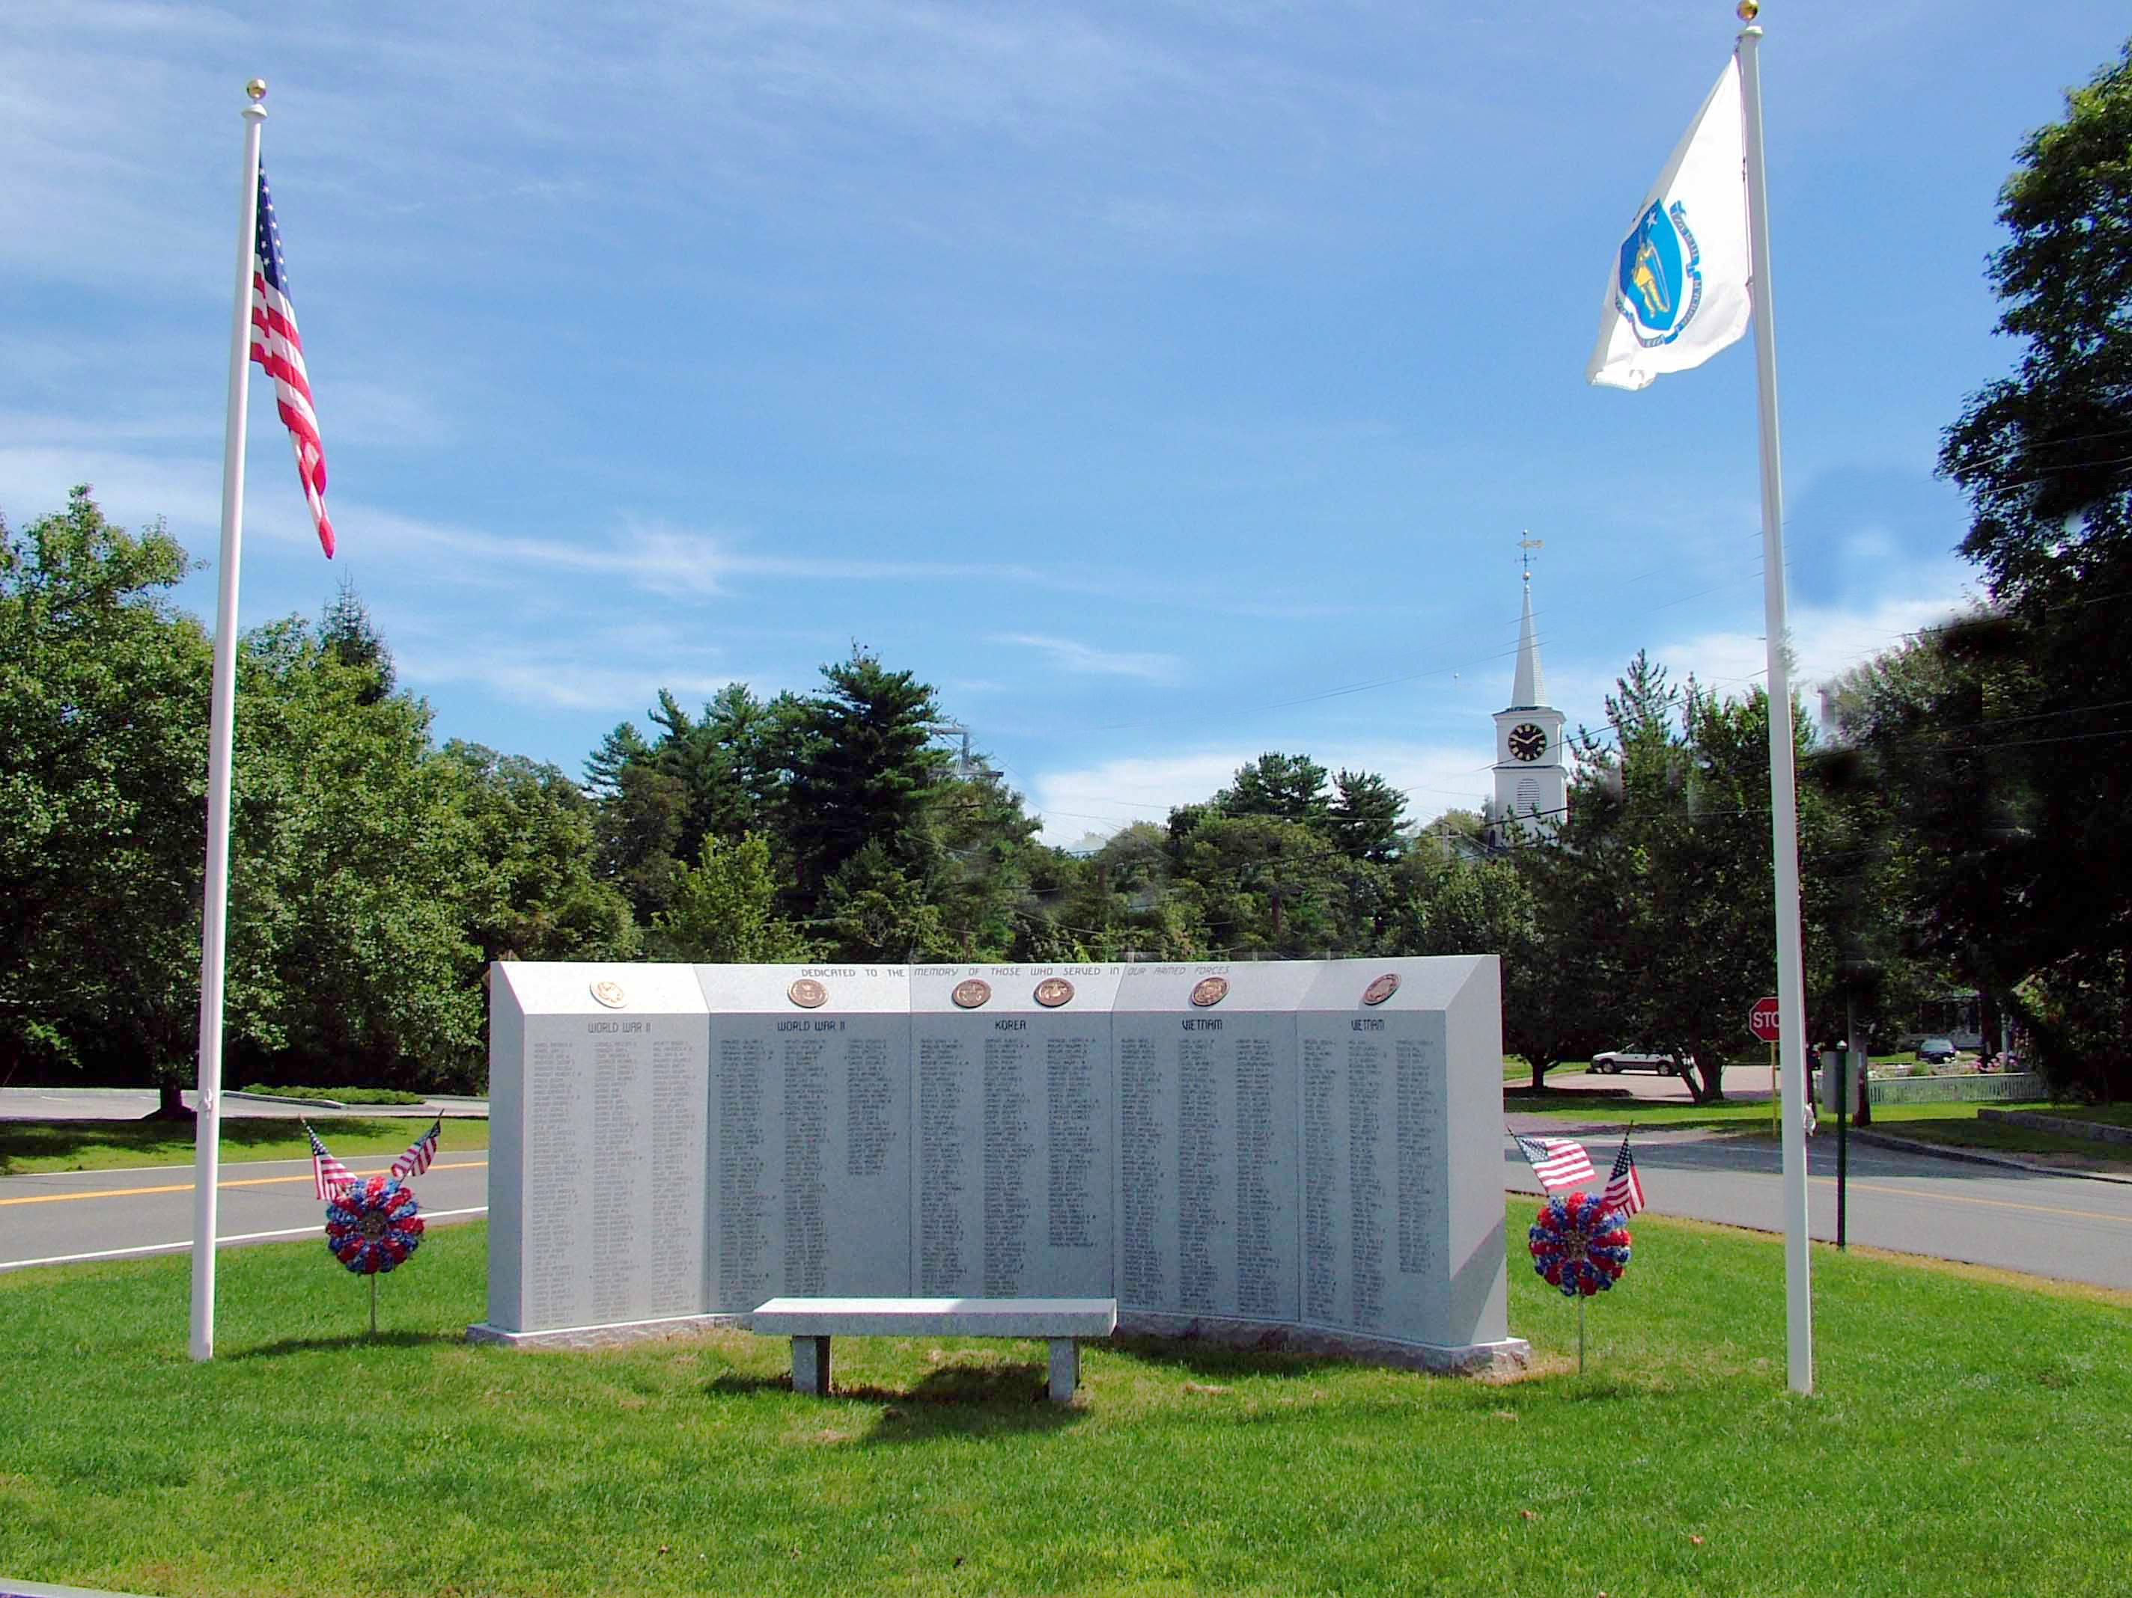

7:00 Open
Call to Order/Pledge of Allegiance
7:30 Citizen Comments
Approval of Minutes
Appointments

Board of Registrars Applicants:
7:35 Bruce Burgess
7:40 Kevin Jones
7:45 Jill O’Loughlin

Old Business

New Business
- Accept Resignation – Brian Noble, Advisory Board
- Beacon Hill Institute Feedback on Green Communities

Upcoming Meetings

Announcements
Norwell ½ Marathon rescheduled to November 16, 2014

Adjournment

Executive Session – Personal Contracts

